LINEAR REGRESSION MODELING
TASK 1
Kiara A Ganger
Western Governors University
D208 | Predictive Modeling

Part I: Research Question

Purpose of Data Analysis

Question:
What factors impact the Monthly Charge for customers in a telecommunications company?

The goals of Data Analysis:
The goals of this analysis are
- Identify what variables contribute to the difference in Monthly Charge
- Develop a multiple linear regression model to predict Monthly Charge based on customer demographics, account information, and service usage.
- Provide feedback to improve pricing strategies and customer service.

Part II: Method Justification

Description of multiple linear regression methods

Assumptions of multiple linear regression:
Summary of four assumptions:
- Linearity:
The relationship between the dependent variable (Monthly Charge) and the independent variables is linear.
- Independence:
Observations are independent of each other.
- Homoscedasticity:
The variance of residuals is constant across all levels of the independent variables.
- Normality:
The residuals are normally distributed.
(Bobbitt, The Five Assumptions of Multiple Linear Regression, 2021)

Benefits of using R
- R provides statistical analysis tools and awesome visualization packages such as ggplot2 for creating detailed plots and dplyr for data manipulation
- The ‘caret’ package in R is useful for machine learning and model training.
- R has a large and active community, offering extensive resources and support for troubleshooting and improving analysis techniques. While will help me in breaking down and better under the codes used.
(Harris, 2023).

Why is multiple linear regression an appropriate technique:
Multiple linear regression is appropriate because it will help me to understand the relationship between the dependent variable ‘MonthlyCharge’ and multiple independent variables such as demographics, account information, and services used . It helps in identifying key factors that significantly influence the Monthly Charge. Multiple linear regression is also useful for making predictions. “Multiple linear regression is preferable when the outcome is influenced by more than one factor because it can account for the impact of multiple variables simultaneously” (Solomon, 2024).

Part III: Data Preparation

Summarize The Data Preparation

Data Cleaning Goals and Steps:
Goal for Data Cleaning:
- Treat Any duplicates
- Treat Any Missing Values including NULLS
- Treat Any Outliers
- Correct Data Types
- Ensure Data Consistency
The steps used to achieve the goals:
Here I used codes from my Task 1 in D206. I ran codes to dedicate any duplicates, to find missing values and outliers and then treated any of the problems found. For example, I treated the outliers with the z-score using statistical method. By doing this, it allowed the distribution of the variable to not be affected. I dropped the population of 0 because it was less than 1%. Then converted all the categorical variables I will be using into factors. “When performing regression analysis or any statistical modeling in R, factors ensure that categorical variables are correctly interpreted, allowing models to account for categorical variations in the data” (Tüzen, 2024). I renamed the Iteam1, Iteam2… Iteam8 columns for better understanding, and added Zeros to the beginning of the values in the Zip column, because they were missing.
Code:
1. #Part C1.
2. # Install the tidyverse package
3. install.packages("tidyverse")
4. install.packages("caret")
5.
6. #Load the ggplot2 and tidyverse library
7. library(tidyverse)
8. library(ggplot2)
9. library(caret)
10. library(magrittr)
11. library(readr)
12. library(car)
13.
14. #Import the churn data
15. churn <-
16. read.csv("C:/Users/kiara/OneDrive/WGU MSDA/churn_clean.csv")
17. View(churn)
18.
19. #Getting to know the DATA
20. summary(churn)
21.
22. # Detecting Duplicates
23. duplicates <- duplicated(churn)
24. duplicate_count <- sum(duplicates)
25. #Print the results
26. print(duplicate_count)
27.
28. # Missing count per column
29. colSums(is.na(churn))
30. #treating hidden missing values
31. pop_percentage_of_zeros <- sum(churn$Population == 0) / nrow(churn) * 100
32. print(pop_percentage_of_zeros)
33. #since under 1% drop
34. churn <- subset(churn, Population != 0)
35.
36. # Remove outliers
37. convars <- c(
38. 'Tenure',
39. 'Children',
40. 'Age',
41. 'Income',
42. 'Email',
43. 'Population',
44. 'Outage_sec_perweek',
45. 'Contacts',
46. 'Yearly_equip_failure',
47. 'Bandwidth_GB_Year',
48. 'MonthlyCharge'
49. )
50. churn <- churn %>%
51. filter(if_any(all_of(convars), ~ abs(. - mean(.)) <= 3 * sd(.)))
52.
53. #the renaming of the survey columns Item1, Item2 etc.
54. churn %<>% rename(
55. Timely_Response = Item1,
56. Timely_Fixes = Item2,
57. Timely_Replacements = Item3,
58. Reliability = Item4,
59. Options = Item5,
60. Respectful_Response = Item6,
61. Courteous_Exchange = Item7,
62. Active_Listening = Item8
63. )
64. #Zip formatted as a five-digit string with leading zeros if necessary
65. churn$Zip <- sprintf("%05d", churn$Zip)
66.
67. # Convert categorical variables to factors
68. churn$Area <- as.factor(churn$Area)
69. churn$Gender <- as.factor(churn$Gender)
70. churn$Contract <- as.factor(churn$Contract)
71. churn$Port_modem <- as.factor(churn$Port_modem)
72. churn$Tablet <- as.factor(churn$Tablet)
73. churn$InternetService <- as.factor(churn$InternetService)
74. churn$Phone <- as.factor(churn$Phone)
75. churn$Multiple <- as.factor(churn$Multiple)
76. churn$OnlineSecurity <- as.factor(churn$OnlineSecurity)
77. churn$OnlineBackup <- as.factor(churn$OnlineBackup)
78. churn$DeviceProtection <- as.factor(churn$DeviceProtection)
79. churn$TechSupport <- as.factor(churn$TechSupport)
80. churn$StreamingTV <- as.factor(churn$StreamingTV)
81. churn$StreamingMovies <- as.factor(churn$StreamingMovies)
82.
83. #Part C2.
84. summary(churn$MonthlyCharge)
85. summary(churn[c(
86. "Tenure",
87. "Children",
88. "Age",
89. "Email",
90. "Population",
91. "Bandwidth_GB_Year",
92. "Port_modem",
93. "Tablet",
94. "InternetService",
95. "Phone",
96. "OnlineSecurity",
97. "OnlineBackup",
98. "DeviceProtection",
99. "TechSupport",
100. "StreamingTV",
101. "StreamingMovies"
102. )])
103.
104. #Part C3.
105. # Univariate Visualization
106. ggplot(churn, aes(x = MonthlyCharge)) +
107. geom_histogram(binwidth = 5,
108. fill = "#7AC5CD",
109. color = "black") +
110. ggtitle("Distribution of Monthly Charge")
111.
112. ggplot(churn, aes(x = Tenure)) +
113. geom_histogram(binwidth = 5,
114. fill = "salmon",
115. color = "black") +
116. ggtitle("Distribution of Tenure")
117.
118. ggplot(churn, aes(x = Children)) +
119. geom_histogram(binwidth = 1,
120. fill = "#7FFFD4",
121. color = "black") +
122. ggtitle("Distribution of Children")
123.
124. ggplot(churn, aes(x = Age)) +
125. geom_histogram(binwidth = 5,
126. fill = "burlywood",
127. color = "black") +
128. ggtitle("Distribution of Age")
129.
130. ggplot(churn, aes(x = Email)) +
131. geom_histogram(
132. binwidth = 5,
133. fill = "darkseagreen",
134. color = "black"
135. ) +
136. ggtitle("Distribution of Email")
137.
138. ggplot(churn, aes(x = Population)) +
139. geom_histogram(binwidth = 10000,
140. fill = "chocolate",
141. color = "black") +
142. ggtitle("Distribution of Population")
143.
144. ggplot(churn, aes(x = Bandwidth_GB_Year)) +
145. geom_histogram(
146. binwidth = 200,
147. fill = "darkslategray",
148. color = "black"
149. ) +
150. ggtitle("Distribution of Bandwidth GB Year")
151.
152. ggplot(churn, aes(x = Port_modem, fill = Port_modem)) +
153. geom_bar() +
154. ggtitle("Distribution of Port Modem") +
155. scale_fill_manual(values = c("Yes" = "deepskyblue", "No" = "deepskyblue4"))
156.
157. ggplot(churn, aes(x = Tablet, fill = Tablet)) +
158. geom_bar() +
159. ggtitle("Distribution of Tablet") +
160. scale_fill_manual(values = c("Yes" = "honeydew", "No" = "honeydew4"))
161.
162. ggplot(churn, aes(x = InternetService, fill = InternetService)) +
163. geom_bar() +
164. ggtitle("Distribution of Internet Service") +
165. scale_fill_manual(
166. values = c(
167. "DSL" = "lemonchiffon3",
168. "None" = "lemonchiffon",
169. "Fiber Optic" = "lemonchiffon4"
170. )
171. )
172.
173. ggplot(churn, aes(x = Phone, fill = Phone)) +
174. geom_bar() +
175. ggtitle("Distribution of Phone") +
176. scale_fill_manual(values = c(
177. "Yes" = "lavenderblush",
178. "No" = "lavenderblush4"
179. ))
180.
181. ggplot(churn, aes(x = OnlineSecurity, fill = OnlineSecurity)) +
182. geom_bar() +
183. ggtitle("Distribution of Online Security") +
184. scale_fill_manual(values = c("Yes" = "pink", "No" = "pink4"))
185.
186. ggplot(churn, aes(x = OnlineBackup, fill = OnlineBackup)) +
187. geom_bar() +
188. ggtitle("Distribution of Online Backup") +
189. scale_fill_manual(values = c("Yes" = "goldenrod1", "No" = "goldenrod4"))
190.
191. ggplot(churn, aes(x = DeviceProtection, fill = DeviceProtection)) +
192. geom_bar() +
193. ggtitle("Distribution of Device Protection") +
194. scale_fill_manual(values = c("Yes" = "green", "No" = "green4"))
195.
196. ggplot(churn, aes(x = TechSupport, fill = TechSupport)) +
197. geom_bar() +
198. ggtitle("Distribution of Tech Support") +
199. scale_fill_manual(values = c("Yes" = "snow", "No" = "snow4"))
200.
201. ggplot(churn, aes(x = StreamingTV, fill = StreamingTV)) +
202. geom_bar() +
203. ggtitle("Distribution of Streaming TV") +
204. scale_fill_manual(values = c("Yes" = "purple", "No" = "purple4"))
205.
206. ggplot(churn, aes(x = StreamingMovies, fill = StreamingMovies)) +
207. geom_bar() +
208. ggtitle("Distribution of Streaming Movies") +
209. scale_fill_manual(values = c("Yes" = "aquamarine4", "No" = "aquamarine"))
210.
211. # Bivariate Visualizations between MonthlyCharge and other variables
212. ggplot(churn, aes(x = Tenure, y = MonthlyCharge)) +
213. geom_point(color = "#7AC5CD") +
214. ggtitle("Monthly Charge vs Tenure")
215.
216. ggplot(churn, aes(x = Children, y = MonthlyCharge)) +
217. geom_point(color = "#7FFFD4") +
218. ggtitle("Monthly Charge vs Children")
219.
220. ggplot(churn, aes(x = Age, y = MonthlyCharge)) +
221. geom_point(color = "burlywood") +
222. ggtitle("Monthly Charge vs Age")
223.
224. ggplot(churn, aes(x = Email, y = MonthlyCharge)) +
225. geom_point(color = "darkseagreen") +
226. ggtitle("Monthly Charge vs Email")
227.
228. ggplot(churn, aes(x = Population, y = MonthlyCharge)) +
229. geom_point(color = "chocolate") +
230. ggtitle("Monthly Charge vs Population")
231.
232. ggplot(churn, aes(x = Bandwidth_GB_Year, y = MonthlyCharge)) +
233. geom_point(color = "darkslategray") +
234. ggtitle("Monthly Charge vs Bandwidth GB Year")
235.
236. ggplot(churn, aes(x = Port_modem, y = MonthlyCharge, fill = Port_modem)) +
237. geom_boxplot() +
238. ggtitle("Monthly Charge vs Port Modem") +
239. scale_fill_manual(values = c("Yes" = "deepskyblue", "No" = "deepskyblue4"))
240.
241. ggplot(churn, aes(x = Tablet, y = MonthlyCharge, fill = Tablet)) +
242. geom_boxplot() +
243. ggtitle("Monthly Charge vs Tablet") +
244. scale_fill_manual(values = c("Yes" = "honeydew", "No" = "honeydew4"))
245.
246. ggplot(churn,
247. aes(x = InternetService, y = MonthlyCharge, fill = InternetService)) +
248. geom_boxplot() +
249. ggtitle("Monthly Charge vs Internet Service") +
250. scale_fill_manual(
251. values = c(
252. "DSL" = "lemonchiffon3",
253. "None" = "lemonchiffon",
254. "Fiber Optic" = "lemonchiffon4"
255. )
256. )
257.
258. ggplot(churn, aes(x = Phone, y = MonthlyCharge, fill = Phone)) +
259. geom_boxplot() +
260. ggtitle("Monthly Charge vs Phone") +
261. scale_fill_manual(values = c(
262. "Yes" = "lavenderblush",
263. "No" = "lavenderblush4"
264. ))
265.
266. ggplot(churn,
267. aes(x = OnlineSecurity, y = MonthlyCharge, fill = OnlineSecurity)) +
268. geom_boxplot() +
269. ggtitle("Monthly Charge vs Online Security") +
270. scale_fill_manual(values = c("Yes" = "pink", "No" = "pink4"))
271.
272. ggplot(churn,
273. aes(x = OnlineBackup, y = MonthlyCharge, fill = OnlineBackup)) +
274. geom_boxplot() +
275. ggtitle("Monthly Charge vs Online Backup") +
276. scale_fill_manual(values = c("Yes" = "goldenrod1", "No" = "goldenrod4"))
277.
278. ggplot(churn,
279. aes(x = DeviceProtection, y = MonthlyCharge, fill = DeviceProtection)) +
280. geom_boxplot() +
281. ggtitle("Monthly Charge vs Device Protection") +
282. scale_fill_manual(values = c("Yes" = "green", "No" = "green4"))
283.
284. ggplot(churn, aes(x = TechSupport, y = MonthlyCharge, fill = TechSupport)) +
285. geom_boxplot() +
286. ggtitle("Monthly Charge vs Tech Support") +
287. scale_fill_manual(values = c("Yes" = "snow", "No" = "snow4"))
288.
289. ggplot(churn, aes(x = StreamingTV, y = MonthlyCharge, fill = StreamingTV)) +
290. geom_boxplot() +
291. ggtitle("Monthly Charge vs Streaming TV") +
292. scale_fill_manual(values = c("Yes" = "purple", "No" = "purple4"))
293.
294. ggplot(churn,
295. aes(x = StreamingMovies, y = MonthlyCharge, fill = StreamingMovies)) +
296. geom_boxplot() +
297. ggtitle("Monthly Charge vs Streaming Movies") +
298. scale_fill_manual(values = c("Yes" = "aquamarine4", "No" = "aquamarine"))
299.

Summary Statistics of Variables
To see the summary of each variable being used I use the summary() function. This provided me with the mean, min, max, standard deviation etc.
- Dependent Variable:
Monthly Charge.
- Independent Variables:
Tenure, Children, Age, Email, Population, Bandwidth_GB_Year, Port Modem, Tablet, Internet Service, Phone, Online Security, Online Backup, Device Protection, Tech Support, Streaming TV, and Streaming Movies.
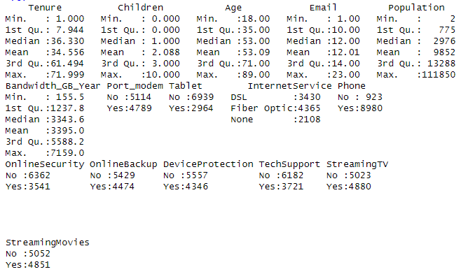

Univariate and Bivariate Visualizations:
Univariate Visualizations
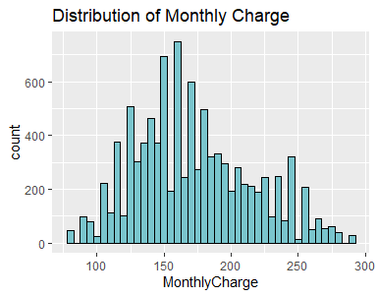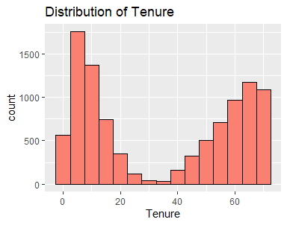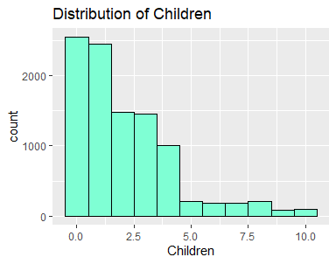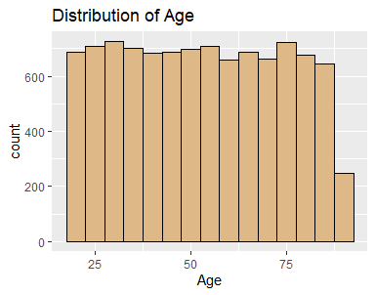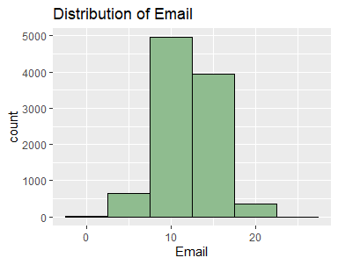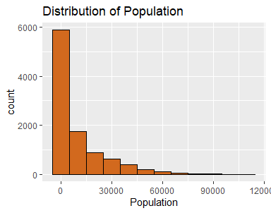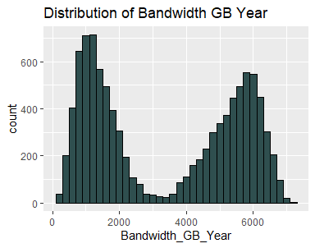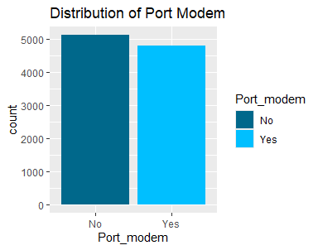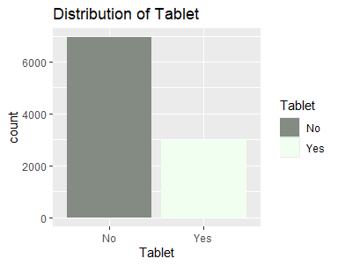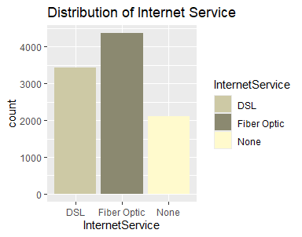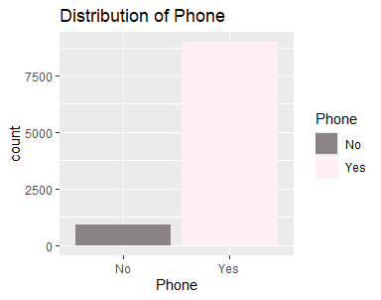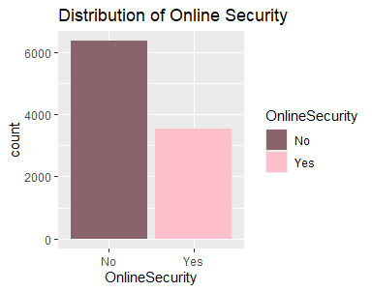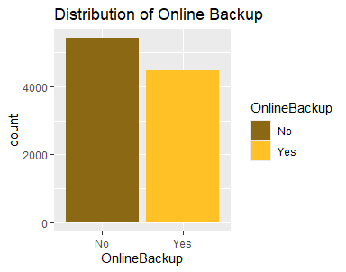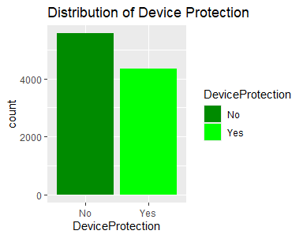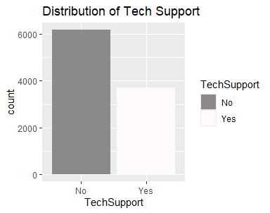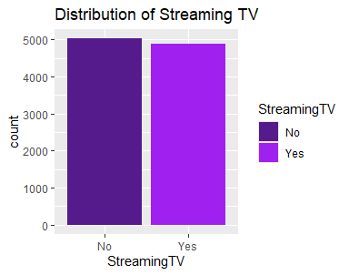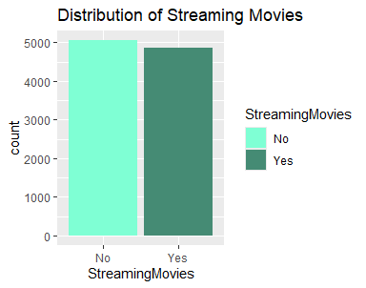
Bivariate Visualizations
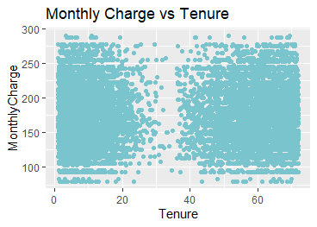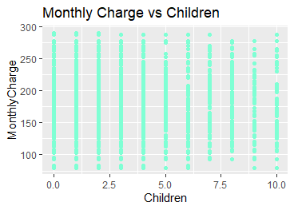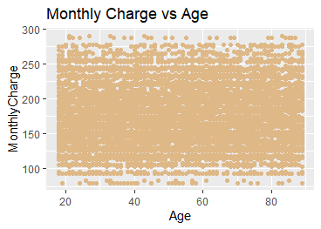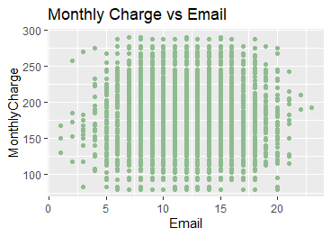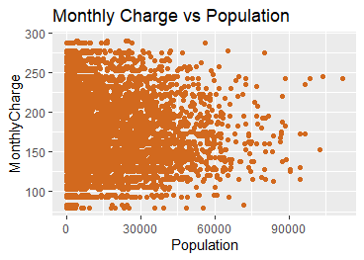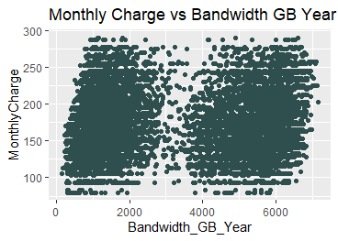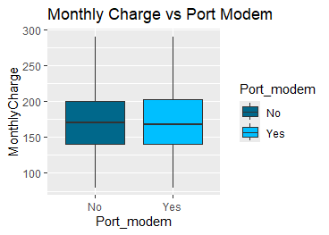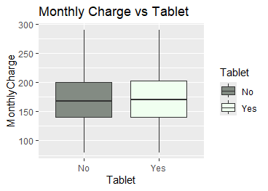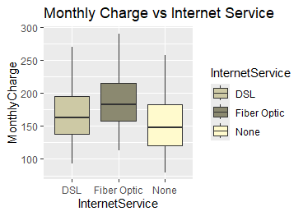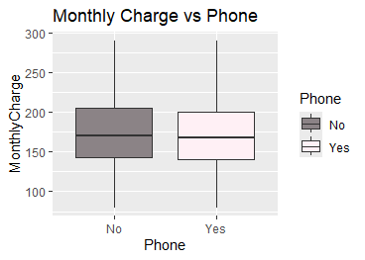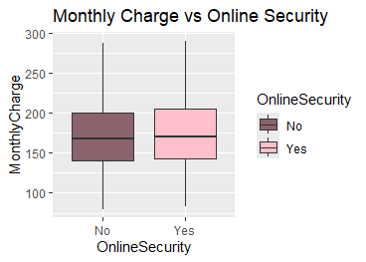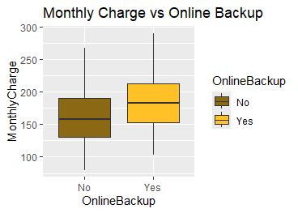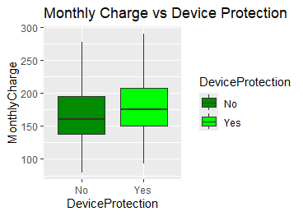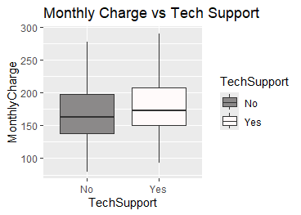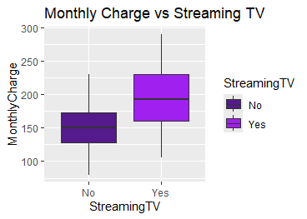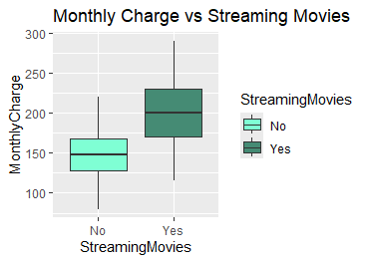

Describe your data transformation goals and steps.
Goals for Data Transformation:
- Make the model’s preditors more interpretable.
- To meet the model’s assumption (such as linearity, equal variance and normality of the residuals).
- Improve the model’s generalizability and predictive power.
- Use encoding to change categorical data into nominal data.
(Choueiry, 2021)
Steps used to transform the Data:
The steps I took to transform the data was using Ordinal Encoding to transform the columns that had a binary value of yes and no. I then finished off with One Hot Encoding for the columns Internet Service, Gender, Area, and Contract, because those columns had more then two options and were not ordinal. I edited the column’s name that were affected by the encoding for easy of coding. And created a subset of the data to separate the variables I will be using for the liner regression analysis. Making sure to exclude one column from each the columns created by the One Hot Encoding. Those columns being Contract_One_Year, InterService_None, Gender_Nonbinary and Area_Urban.
Code:
1. # Part C4.
2. # Apply label encoding to other categorical variables
3. churn <- churn %>%
4. mutate(
5. Port_modem = ifelse(Port_modem == "Yes", 1, 0),
6. Tablet = ifelse(Tablet == "Yes", 1, 0),
7. Phone = ifelse(Phone == "Yes", 1, 0),
8. OnlineSecurity = ifelse(OnlineSecurity == "Yes", 1, 0),
9. OnlineBackup = ifelse(OnlineBackup == "Yes", 1, 0),
10. DeviceProtection = ifelse(DeviceProtection == "Yes", 1, 0),
11. TechSupport = ifelse(TechSupport == "Yes", 1, 0),
12. StreamingTV = ifelse(StreamingTV == "Yes", 1, 0),
13. StreamingMovies = ifelse(StreamingMovies == "Yes", 1, 0)
14. )
16. # One Hot Encode
17. internet_dummies <- model.matrix( ~ InternetService - 1, data = churn)
18. churn <- cbind(churn, internet_dummies)
19. churn <- churn %>% select(-InternetService)
21. # Rename the column for better coding
22. churn <- churn %>%
23. rename(
24. InternetService_None = `InternetServiceNone`,
25. InternetService_Fiber_Optic = `InternetServiceFiber Optic`,
26. InternetService_DSL = `InternetServiceDSL`
27. )
29. # Subset of the Dataset with the variables for my initial model
30. # Exclude reference categories for dummy variables
31. variables_used <- c(
32. "MonthlyCharge",
33. "Tenure",
34. "Children",
35. "Age",
36. "Email",
37. "Population",
38. "Bandwidth_GB_Year",
39. "Port_modem",
40. "Tablet",
41. "InternetService_Fiber_Optic",
42. "InternetService_DSL",
43. "Phone",
44. "OnlineSecurity",
45. "OnlineBackup",
46. "DeviceProtection",
47. "TechSupport",
48. "StreamingTV",
49. "StreamingMovies"
50. )
51. task_1 <- churn[variables_used]
52. write.csv(task_1, file = "C:/Users/kiara/OneDrive/WGU MSDA/D208/task_2.csv", row.names = FALSE)
53. task_1 <- read.csv("C:/Users/kiara/OneDrive/WGU MSDA/D208/task_2.csv")
54. view(task_1)

Prepared data set
File: task_1

Part IV: Model Comparison and Analysis

Compare an initial and a reduced linear regression model

Initial multiple linear regression model
To construct an initial multiple linear regression model, I will be using the following coding formula . “lm(response_variable ~ predictor_variable1 + predictor_variable2 + ..., data = data)” (Bobbitt, How to Perform Multiple Linear Regression in R, 2019)
Code:
1. # Part D1.
2. initial_model <- lm(
3. MonthlyCharge ~ Tenure + Children + Age + Email + Population + Bandwidth_GB_Year + Port_modem + Tablet +
4. InternetService_Fiber_Optic + InternetService_DSL + Phone + OnlineSecurity + OnlineBackup +
5. DeviceProtection + TechSupport + StreamingTV + StreamingMovies,
6. data = task_1
7. )
8. summary(initial_model)
9. vif(initial_model)
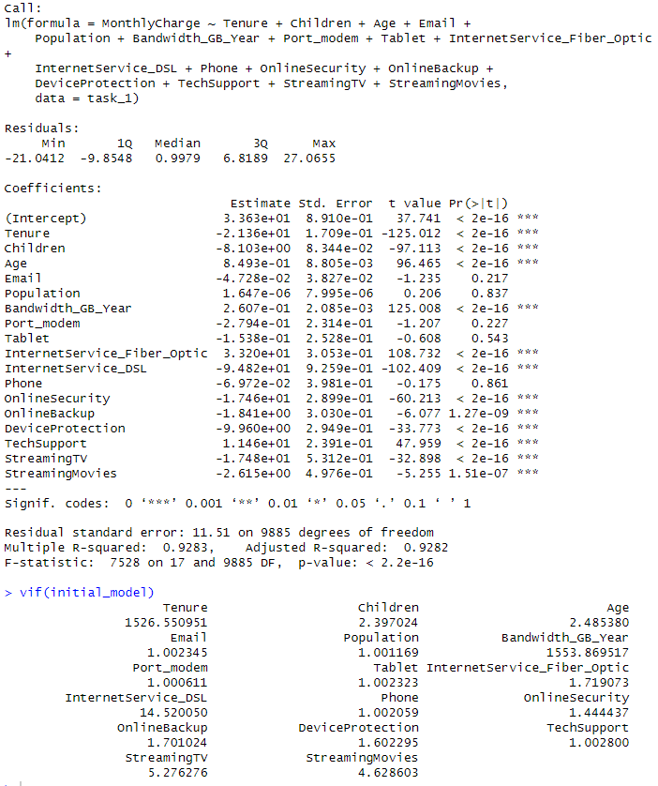

Feature Selection Procedure
For feature selection, I used VIF and Backward Stepwise Elimination method to refine the initial model. I started by removing the predictor with the highest vif value first and repeating the process until all the vif values are under 10. In this case it wilk be the predictor Bandwidth GB Year. Once that is taken care of, I started removing based on p-value. Here I did the same process of removing one at a time and repeating the code. This method is justified, because it keeps the predictors that have a statistical significance to the dependent variable.

Reduced Linear Regression Model
1. # Part D3.
2. # Remove Bandwidth_GB_Year
3. red_mod_01 <- lm(
4. MonthlyCharge ~ Tenure + Children + Age + Email + Population + Port_modem + Tablet +
5. InternetService_Fiber_Optic + InternetService_DSL + Phone + OnlineSecurity + OnlineBackup +
6. DeviceProtection + TechSupport + StreamingTV + StreamingMovies,
7. data = task_1
8. )
9. summary(red_mod_01)
10. vif(red_mod_01)
11. 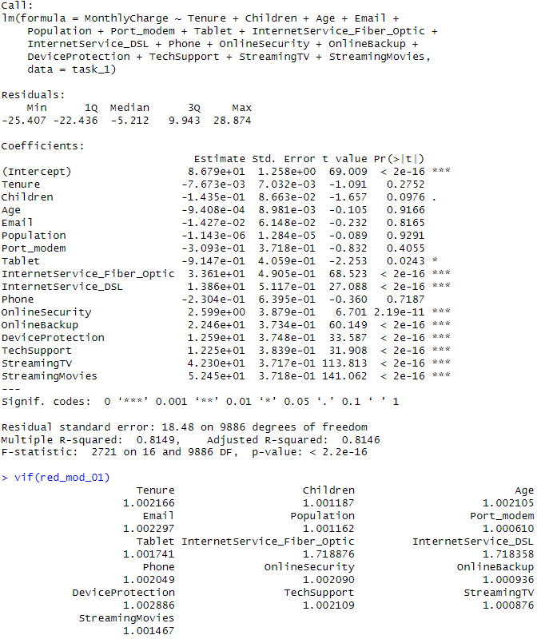
12. # Remove Population
13. red_mod_02 <- lm(
14. MonthlyCharge ~ Tenure + Children + Age + Email + Port_modem + Tablet +
15. InternetService_Fiber_Optic + InternetService_DSL + Phone + OnlineSecurity + OnlineBackup +
16. DeviceProtection + TechSupport + StreamingTV + StreamingMovies,
17. data = task_1
18. )
19. summary(red_mod_02)
20. vif(red_mod_02)
21. 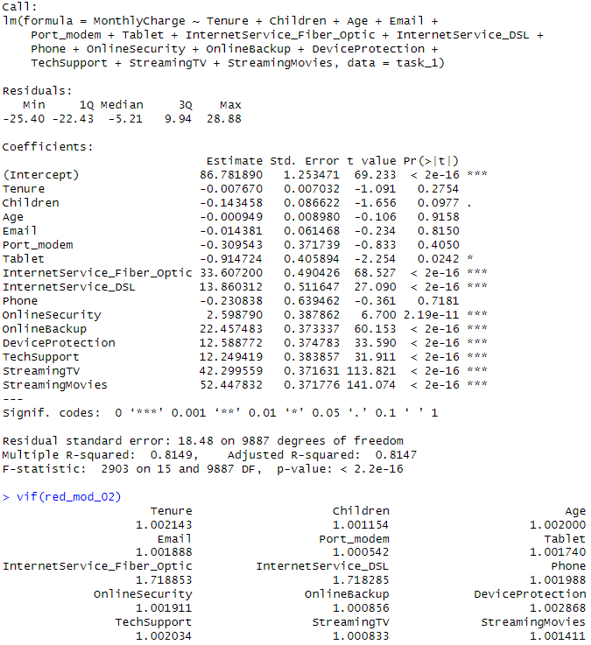
22. # Remove Age
23. red_mod_03 <- lm(
24. MonthlyCharge ~ Tenure + Children + Email + Port_modem + Tablet +
25. InternetService_Fiber_Optic + InternetService_DSL + Phone + OnlineSecurity + OnlineBackup +
26. DeviceProtection + TechSupport + StreamingTV + StreamingMovies,
27. data = task_1
28. )
29. summary(red_mod_03)
30. vif(red_mod_03)
31. 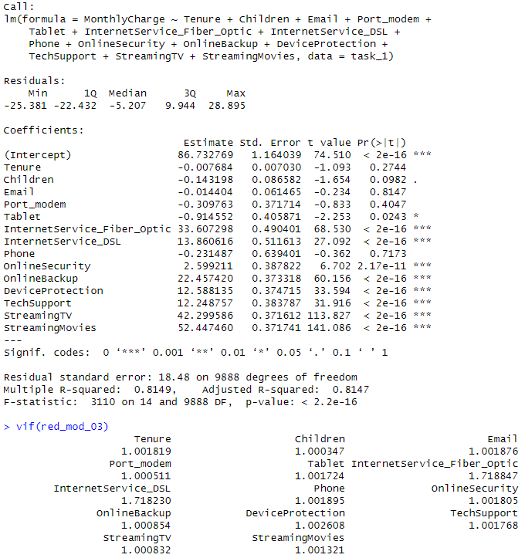
32. # Remove Email
33. red_mod_04 <- lm(
34. MonthlyCharge ~ Tenure + Children + Port_modem + Tablet +
35. InternetService_Fiber_Optic + InternetService_DSL + Phone + OnlineSecurity + OnlineBackup +
36. DeviceProtection + TechSupport + StreamingTV + StreamingMovies,
37. data = task_1
38. )
39. summary(red_mod_04)
40. vif(red_mod_04)
41. 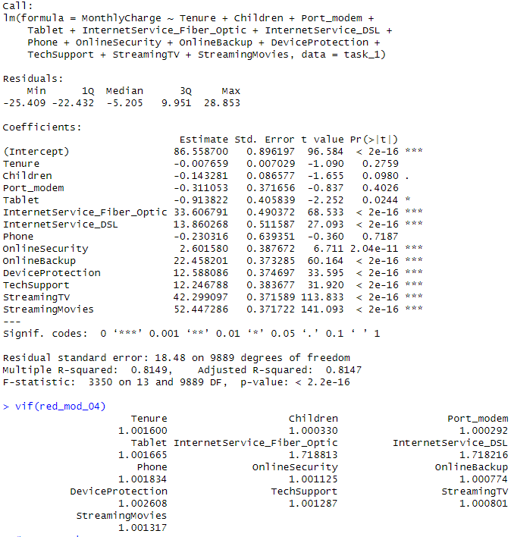
42. # Remove Phone
43. red_mod_05 <- lm(
44. MonthlyCharge ~ Tenure + Children + Port_modem + Tablet +
45. InternetService_Fiber_Optic + InternetService_DSL + OnlineSecurity + OnlineBackup +
46. DeviceProtection + TechSupport + StreamingTV + StreamingMovies,
47. data = task_1
48. )
49. summary(red_mod_05)
50. vif(red_mod_05)
51. 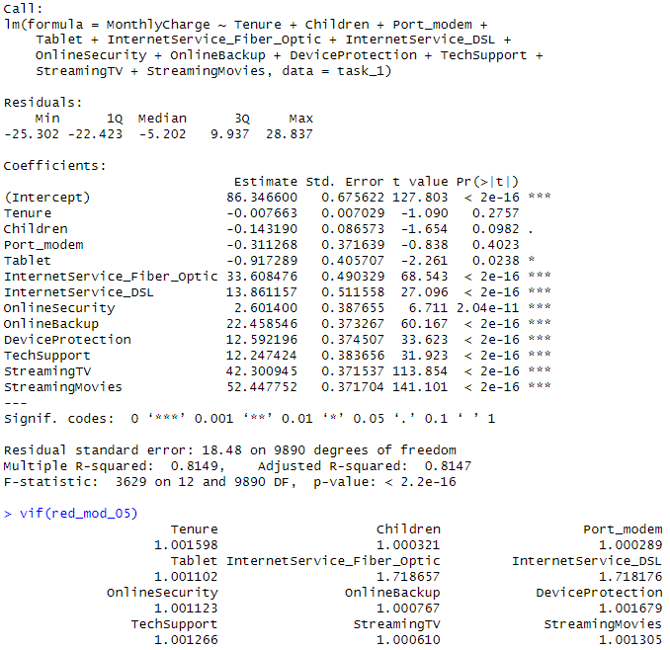
52. # Remove Port_modem
53. red_mod_06 <- lm(
54. MonthlyCharge ~ Tenure + Children + Tablet +
55. InternetService_Fiber_Optic + InternetService_DSL + OnlineSecurity + OnlineBackup +
56. DeviceProtection + TechSupport + StreamingTV + StreamingMovies,
57. data = task_1
58. )
59. summary(red_mod_06)
60. vif(red_mod_06)
61. 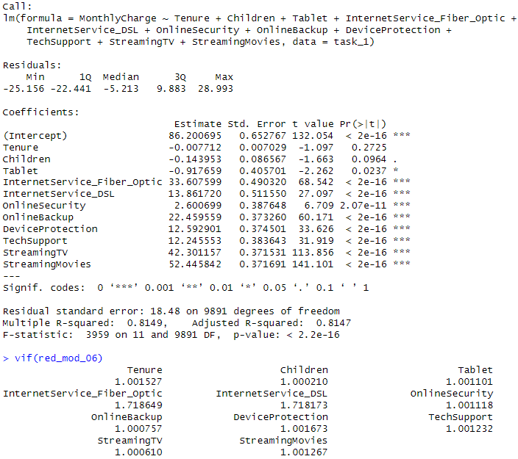
62. # Remove Tenure
63. red_mod_07 <- lm(
64. MonthlyCharge ~ Children + Tablet +
65. InternetService_Fiber_Optic + InternetService_DSL + OnlineSecurity + OnlineBackup +
66. DeviceProtection + TechSupport + StreamingTV + StreamingMovies,
67. data = task_1
68. )
69. summary(red_mod_07)
70. vif(red_mod_07)
71. 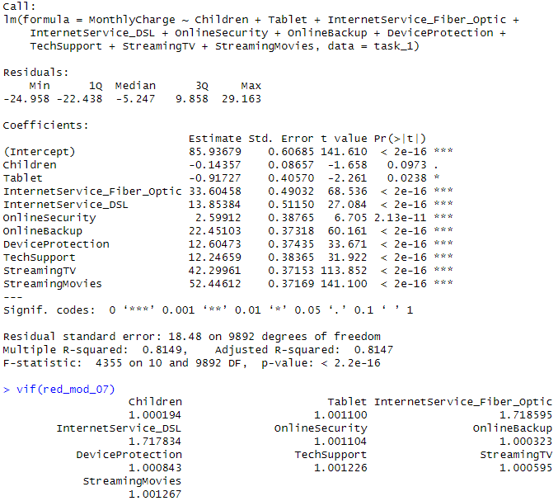
72. # Remove Children
73. red_mod_08 <- lm(
74. MonthlyCharge ~ Tablet +
75. InternetService_Fiber_Optic + InternetService_DSL + OnlineSecurity + OnlineBackup +
76. DeviceProtection + TechSupport + StreamingTV + StreamingMovies,
77. data = task_1
78. )
79. summary(red_mod_08)
80. vif(red_mod_08)
81. 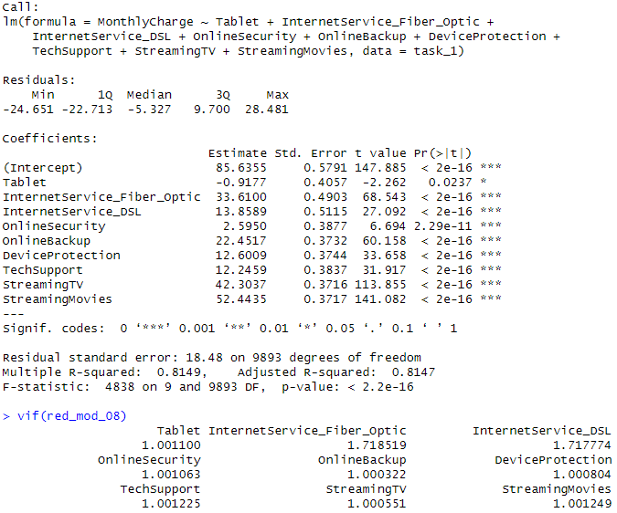
82. # Remove Tablet
83. red_mod_09 <- lm(
84. MonthlyCharge ~ InternetService_Fiber_Optic + InternetService_DSL + OnlineSecurity + OnlineBackup +
85. DeviceProtection + TechSupport + StreamingTV + StreamingMovies,
86. data = task_1
87. )
88. summary(red_mod_09)
89. vif(red_mod_09)
90. 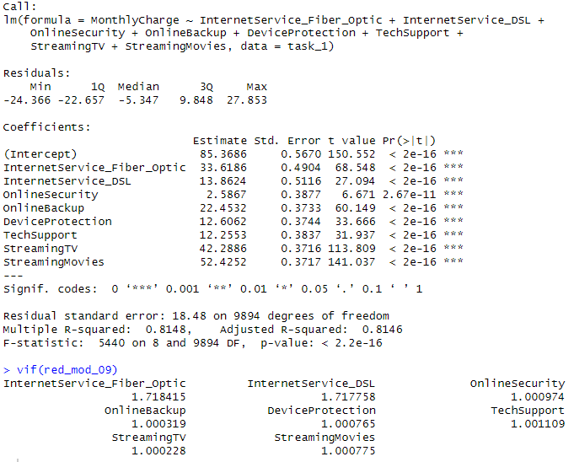

Analyze the data set using your reduced linear regression model

Compare the models.
Number of Predictors:
Initial Model: 17 predictors
Final Model: 8 Predictors
Model Evaluation Metric:
- Adjusted R-squared:
This adjusts the R-squared value based on the number of predicators.
Initial Model: 0.9282
Reduced Model: 0.8146
- Multiple R-squared:
Initial Model: 0.9283
Reduced Model: 0.8148
- Residual Standard Error:
This measured the standard deviation of the residuals. Giving insight into the accuracy of the predictions
Initial Model: 11.51
Reduced Model: 18.48
The RSE values have a .001 difference, meaning that both models have similar predictive accuracy.
- Variance Inflation Factor:
Assesses multicollinearity in the predictors. A VIF value > 10 indicates problematic multicollinearity.
Initial Model: Two predictors had VIF values greater than 10 Tenure and Bandwidth_GB_Year
Reduced Model: All VIF values are close to 1, meaning no multicollinearity issues.
The final model is simpler since it has less predictors. This makes it easier to interpret and use. All the predictors are statistically significant. And VIF values are low.

Provide the output and calculations of the analysis.
1. # Part E2.
2. final_model <- lm(
3. MonthlyCharge ~ InternetService_Fiber_Optic + InternetService_DSL + OnlineSecurity + OnlineBackup +
4. DeviceProtection + TechSupport + StreamingTV + StreamingMovies,
5. data = task_1
6. )
7. summary(final_model)
8. vif(final_model)
9. 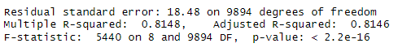
10. # Create the residual plot for the reduced model
11. plot(fitted(final_model), residuals(final_model),
12. main = "Residual Plot for Reduced Model",
13. xlab = "Fitted Values",
14. ylab = "Residuals",
15. pch = 20, col = "blue")
16. abline(h = 0, lty = 2, col = "red")
17. 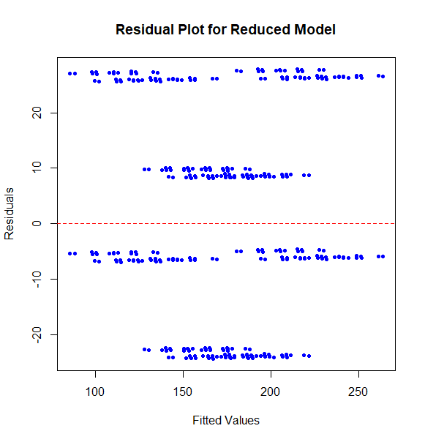
18. # Generate the residuals from the final reduced model
19. residuals_final_model <- residuals(final_model)
24. # Create Q-Q plot for residuals
25. qqplot <- ggplot(data = data.frame(residuals = residuals_final_model), aes(sample = residuals)) +
26. stat_qq() +
27. stat_qq_line(color = "red") +
28. ggtitle("Q-Q Plot of Residuals") +
29. xlab("Theoretical Quantiles") +
30. ylab("Sample Quantiles")
32. # Print the Q-Q plot
33. print(qqplot)
34. 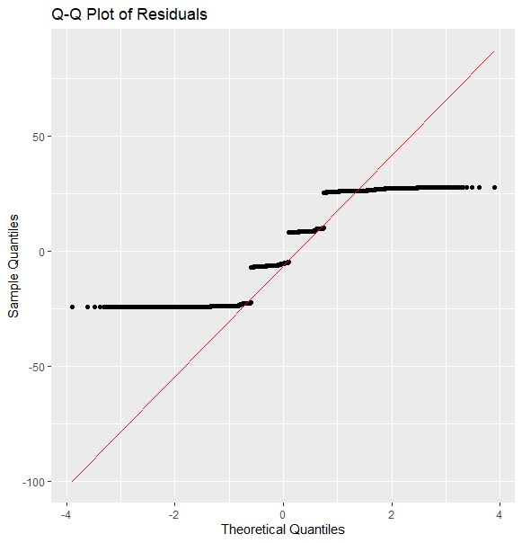

Provide an executable error-free copy of the code.
File: Task 1 Code.2.R

Part V: Data Summary and Implications

Summarize your findings and assumptions

Discuss the results of your data analysis, including the following elements:
- The regression equation for the reduced model is:
$$MonthlyCharge = β0+ β1+ β2+ β3+ β4+β5+ β6+ β7+ β8$$
(Bobbitt, How to Read and Interpret a Regression Table, 2019)
- Interpretation of the Coefficients:
Y-Intercept (85.3686): β0 This is the estimated base monthly charge when all other predictor variables are zero.
Internet Service Fiber Optic (33.6186): β1 Having Fiber Optic increases monthly bill by 33.6$
Internet Service DSL (13.8624): β2 DSL increases monthly bill by 13$
Online Security (2.5867): β3 Online Security increases monthly bill by 2.5$
Online Backup (22.4532): β4 Online Backup increases monthly bill by 22.45$
Device Protection (12.6062): β5 Device Protection increases monthly bill by 12.60$
Tech Support (12.2553): β6 Tech Support increases monthly bill by 12.25$
Streaming TV (42.2886): β7 TV streaming services increase monthly bill by 42.28$
Streaming Movies (52.4252): β8 Movie streaming services increase monthly bill by 52.42$
- Statistical and Practical Significance:
Statistical Significance- The p-values for all the predicators are below 0.05. Meaning they are statistically significant. Making the model Statistically significant.
Practical Significance- The coefficients show how much each factor contributes to the monthly charge. For example, the services streaming movies and TV have a positive impact on the monthly charge, highlighting their importance in determining customer billing. The model is practically significant.
- Limitations of the Data Analysis:
The data quality can be a limitation, because of human error. If the data isn’t treated correctly or too much is removed it can affect the model’s reliability. This data doesn’t take into account external factors like taxes, promotions, or discounts. So, customers’ bills are not accurately represented. Although VIF values in the final model are low, it was a problem in the initial model and to some extent can still exist.

Recommended Course of Action
Based on the results, I would recommend that they focus on promoting services like Streaming TV and Streaming Movies, because they significantly increase the monthly charge. They can use a process called Customer Segmentation. This is when customers are split into groups based on similarities. For example, customers who love to stream movies or TV will likely want higher internet speeds so knowing how to advertise to groups will help the company. Conduct a more analysis of non-linear relationships and how potential interactions effects variables. Regularly update the model with new data.

Part VI: Demonstration

Panopto video
Link: https://wgu.hosted.panopto.com/Panopto/Pages/Viewer.aspx?id=16074b17-5a5a-42e3-b564-b195013aba1e

Sources

Third-Party Code Sources:
Bobbitt, Z. (2019, May 11). How to Perform Multiple Linear Regression in R. Retrieved from statology: https://www.statology.org/multiple-linear-regression-r/#:~:text=The%20basic%20syntax%20to%20fit%20a%20multiple%20linear,disp%20%2B%20hp%20%2B%20drat%2C%20data%20%3D%20data%29
Bobbitt, Z. (2019, March 20). How to Read and Interpret a Regression Table. Retrieved from Statology: https://www.statology.org/read-interpret-regression-table/
Choueiry, G. (2021). 5 Variable Transformations to Improve Your Regression Model. Retrieved from QUANTIFYING HEALTH: https://quantifyinghealth.com/variable-transformations-in-regression/#:~:text=Compared%20to%20fitting%20a%20model%20using%20variables%20in,assessment%20of%20their%20relative%20importance%20in%20the%20model.

Non-Code References
Bobbitt, Z. (2021, November 16). The Five Assumptions of Multiple Linear Regression. Retrieved from Statology: https://www.statology.org/multiple-linear-regression-assumptions/
Bobbitt, Z. (2019, February 23). Understanding Heteroscedasticity in Regression Analysis. Retrieved from Statology: https://www.statology.org/heteroscedasticity-regression/
Harris, J. (2023, September 20). Advantages and Disadvantages of R programming. Retrieved from theknowledgeacademy: https://www.theknowledgeacademy.com/blog/advantages-and-disadvantages-of-r-programming/
Solomon, M. (2024, March 21). Beginner’s Guide to Multiple Linear Regression. Retrieved from Martin Solomon, Machine Learning Specialist: https://martinsolomon.io/guides/multiple-linear-regression/#:~:text=Multiple%20linear%20regression%20helps%20predict%20outcomes%20by%20analyzing,making%20it%20an%20essential%20skill%20for%20data%20scientists.
Tüzen, M. F. (2024, Janaury 10). Cracking the Code of Categorical Data: A Guide to Factors in R. Retrieved from R-bloggers: https://www.r-bloggers.com/2024/01/cracking-the-code-of-categorical-data-a-guide-to-factors-in-r/#:~:text=Statistical%20models%20often%20require%20categorical%20variables%20to%20be,to%20account%20for%20categorical%20variations%20in%20the%20data.

